Supporting Documentation for Group 10

Adam Luong

Benny Mai

Dakota Wessel

Jacky Zheng

Tony Zhu

November 29, 2020

# Bug Reporting through Github:

Results:

* 5 open bugs that did not impact core gameplay
* 13 closed bugs
* 21 total bugs

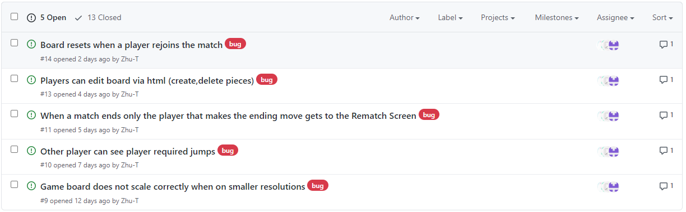

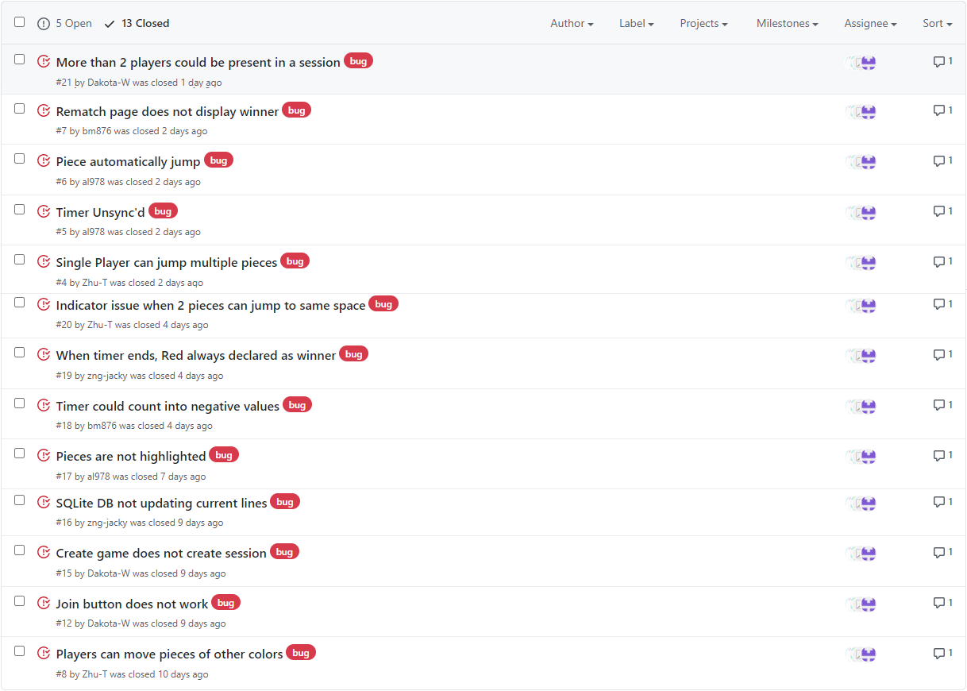

# Static Analysis through ESLint

Attached below is Static Analysis in ESLint :  
   
  
ESLint Config file:  
  
Static Analysis after implementing fixes and using -fix: